INVOICE NO.
913163
Adrian
CONTACT NAME:
ASIAN HARVEST FOODS INVERNESS
COMPANY NAME:
3 Longman Drive,

Inverness
DELIVERY ADDRESS:
POST CODE: IV1 1SU
TEL: 01463 713 888
MOBILE:
ITEM NO. | QTY: | CARTON:
H88-13 | 100 | 2
Total: | 100 | 2
DELIVERY CODE:

SCOTLAND
CUSTOMER SIGN:
DATE: 28 July 2013

VERSION: 01
CHI INTERNATIONAL LTD 大志 2014 CALENDAR ARTWORK CONFIRMATION
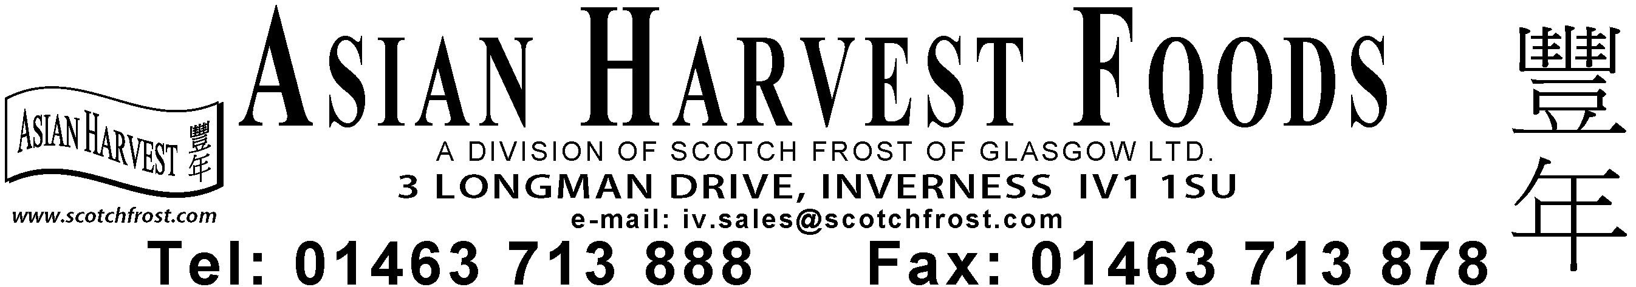
請在7天內寄回此稿及簽名確定資料正確。
Please sign and return the artwork confirmation within 7 days. (If we DO NOT hear from you, we will presume the details are correct and approved.)

